**SKYVIEW JUNIOR SCHOOL – WAKISO**

**MID-TERM EXAMINATIONS 2023**

**PRIMARY TWO MATHEMATICS**

**NAME: _____________________________________**

Each correct answer carries two (2) marks.

**1a).** A ____________________ is a small set from the big set.

(empty set, subset)

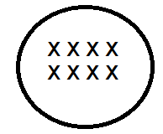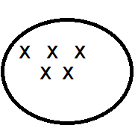**b).** Workout the following.

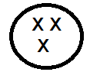

**+ =**

 **5 3 = 8**

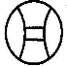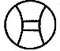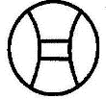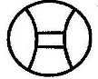

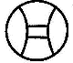 **+ =**



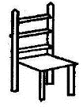

**+ =**

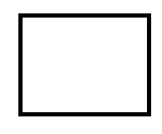

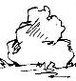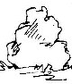****

**-**  **=**



**5 - 2 = 3**



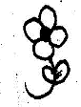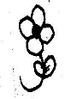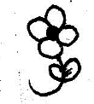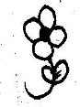

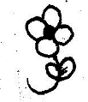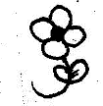 **- =**





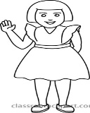

 **- =**

**c).** What is an empty set?

__________________________________________________________

**2.** Name these shapes.

|  |  |  |  |  |
| --- | --- | --- | --- | --- |
|  |  |  |  |  |
|  |  |  |  |  |

(line , cylinder , kite , diamond , zigzag)

**3.** Complete the abacus correctly.

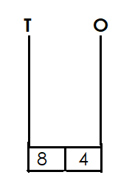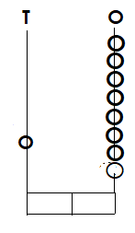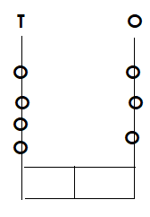

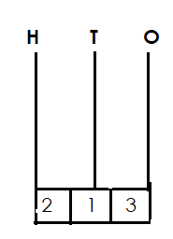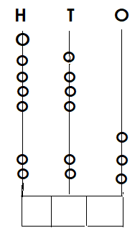

**4**. Fill in the missing numbers.

100, _______, 102, 103, ______, 105,

106, _______, ______, 109, _____.

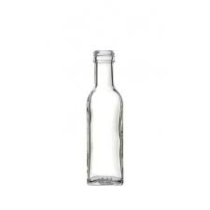**5.** Compare using longer and shorter.

** S**

**T**

Bottle S is _________________ than bottle T.

Bottle T is ________________ than bottle S.

**6.** Read and workout correctly.

**a)** One chair has 4 legs. How many legs do 2 chairs have?

**b)** Eight fingers minus two fingers equals _________________

**c.** Five plus five equals ___________

**7.** Match correctly.

Jan March

Feb April

Mar May

April January

May February

**8.** Write the following in figures.

One hundred = __________

Fifteen = __________

eighty one = ________

sixty four = _________

ninety five = _______

**9.** Fill in the missing dates in the calendar.

February 2023

|  |  |  |  |  |  |  |
| --- | --- | --- | --- | --- | --- | --- |
| **S** | **M** | **T** | **W** | **TH** | **F** | **S** |
|  |  |  | **1** | **2** |  | **4** |
| **5** | **6** | **7** | **8** | **9** | **10** | **_____** |
| **12** | **13** | **14** | **15** | **_____** | **17** | **18** |
| **_____** | **20** | **21** | **_____** | **23** | **24** | **25** |
| **26** | **27** | **28** | **29** |  |  |  |

**10.** The graph below shows children who have books in class.

|  |  |  |  |  |
| --- | --- | --- | --- | --- |
|  |  |  |  |  |
| Sarah | Ritah | Peter | Dorah | Keith |

**Questions.**

**a**) Who has two books?

_____________________________________________________

**b)** ___________ and ____________ have the same number of books.

c) Who has more books?

_____________________________________________________

d) ___________ has four books.

**11.** Add correctly.

5 + 3 = __________ 10 + 8 = __________

5 + 2 = _________

**Shs** 1 0 0 1 5 litres

**+ Shs** 3 0 0  **+** 2 1 litres